Augmatic Technologies – GW Module
Configuration Manual
WIN – GW-2M-2TCP Gateway

Product Overview:
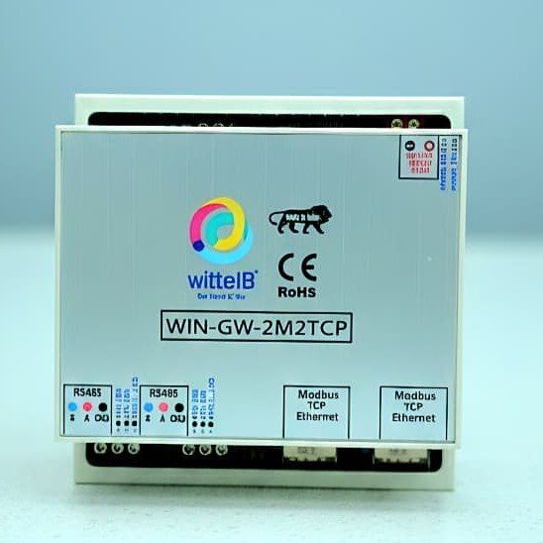

Product Overview:
The RTU to TCP Converter is a highly versatile and efficient dual-channel Modbus gateway designed to convert two independent Modbus RTU (RS485) networks into two separate Modbus TCP connections. This enables seamless integration of legacy serial devices with modern Ethernet-based industrial networks.

Each Modbus RTU channel operates independently and is mapped to its own Modbus TCP interface, allowing two different RTU buses to communicate simultaneously with two TCP/IP networks. The device supports multiple Modbus TCP masters per channel, ensuring reliable data access from SCADA systems, HMIs, PLCs, and cloud applications.

This converter is an ideal solution for industrial environments where multiple serial Modbus networks must be accessed over Ethernet without interference, offering high performance, scalability, and robust communication.
Key Features:
- Dual Modbus RTU to Dual Modbus TCP Gateway: supports 2 independent RS485 Modbus RTU ports mapped to 2 separate Modbus TCP interface.
- Simultaneous Multi-Master Support: Allows multiple Modbus TCP masters (SCADA, HMI, PLC) to access each RTU network concurrently.
- Independent Channel Operation: Each RTU ↔ TCP channel operates independently, ensuring no data collision or cross-communication.
- Windows-Based Configuration Utility: Easy configuration using a WIN tool for serial settings, IP configuration, and protocol parameters.
- Flexible Serial Configuration: Configurable baud rate, parity, stop bits, and slave ID range for each RTU port.
- Ethernet 10/100 Mbps Support: Standard RJ45 Ethernet interface with Modbus TCP over TCP/IP.
- Reliable & Robust Communication: Built-in error handling, timeout management, and automatic reconnection.
- Compact Industrial Design: DIN-rail / panel-mountable form factor (if applicable).
- Wide Application Compatibility: Works with SCADA systems, PLCs, HMIs, energy meters, sensors, and industrial controllers.
Applications:
- Industrial automation systems
- Building management systems
- Energy monitoring and management
- Remote monitoring and control systems
- Process control system
- SCADA and HMI integration
- Machine – to – machine (M2M) Communication
- Manufacturing and Production line monitoring.

Installation & Configuration Procedure:
- Connect 12–24V DC supply to the module.
- Connect Modbus RTU slave devices to the RS485 terminals.
- Connect Ethernet cables to the Ethernet ports of the board.
- Power ON the device, open a web browser on your PC or mobile, and enter Ethernet-1 IP: 192.168.1.254.
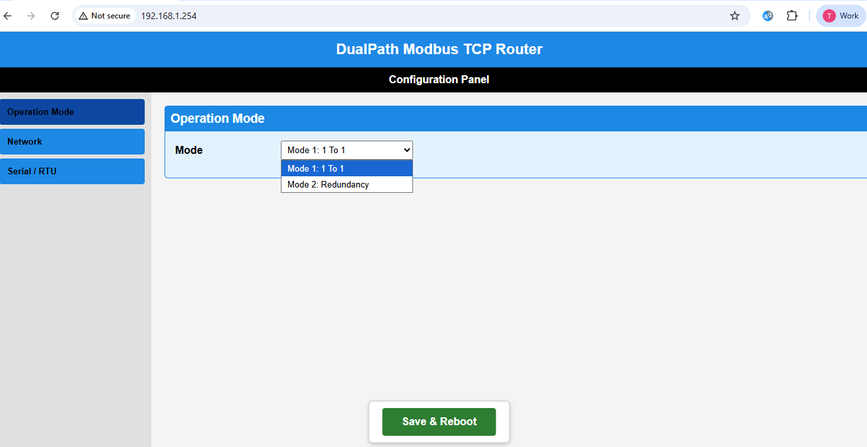
- The webpage configuration interface will open for gateway operation and configuration.
Note -: Ensure Your PC is in same subnet 192.168.1.xxx before accessing the gateway.

- Webpage Configuration Parameters
The gateway provides a built-in web-based configuration interface that allows complete setup of both RTU and Ethernet parameters. Each RTU (RS485) port can be configured independently by setting baud rate, slave ID’s, data bits, parity, and stop bits according to the connected Modbus devices. In addition, Ethernet settings such as IP address, port number, and operating mode (One-to-One or Redundancy) can be modified through the same webpage. All configuration changes can be saved directly from the interface, and the device automatically restarts to apply the new settings.

- Mode-1: One To One
TCP/IP-1 =192.168.1.254:502 → RTU-1
TCP/IP-2 =192.168.1.150:503 → RTU-2

- Mode-2: Redundancy Mode
TCP/IP-1 =192.168.1.254:502 → RTU-1 + RTU-2
TCP/IP-2 =192.168.1.150:503 → RTU-1 + RTU-2
Slave IDs must be different across both RTUs.
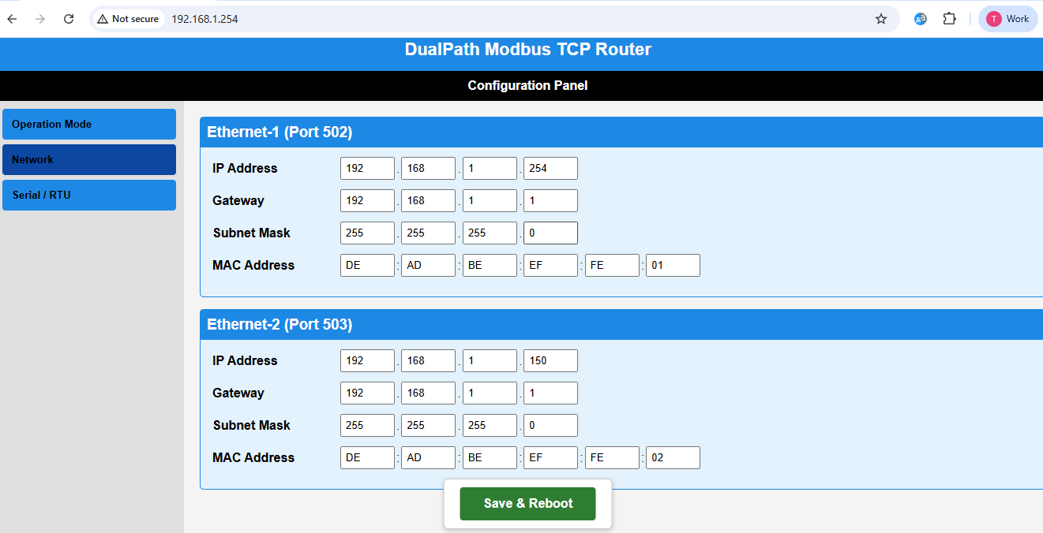
- Default Network Configuration
TCP/IP-1: 192.168.1.254 — Port 502
TCP/IP-2: 192.168.1.150 — Port 503

- Serial RTU Configuration
The gateway provides independent configuration for each RS485 Modbus RTU port through the built-in web interface. Users can configure communication parameters for RTU-1 and RTU-2 separately to match the connected Modbus slave devices.

- The following serial parameters can be configured:
- Baud Rate (e.g., 9600 / 19200 / 38400 / 115200 bps)
- Data Bits (7 or 8 bits)
- Parity (None / Even / Odd)
- Stop Bits (1 or 2)
- Each RTU channel operates independently, allowing two different serial networks with different communication settings to function simultaneously. The gateway supports up to 10 Modbus slave devices per RTU port, ensuring reliable and collision-free communication.

- All configured serial parameters are stored in non-volatile memory after saving, and the device automatically restarts to apply the updated settings
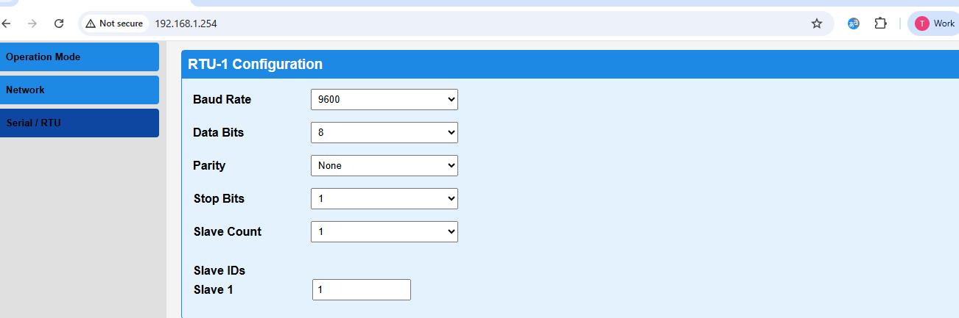

- Save Configuration
Click Save / Submit Configuration after selecting all parameters.
The board will automatically reset within 3 seconds.
All settings are stored in non-volatile memory.
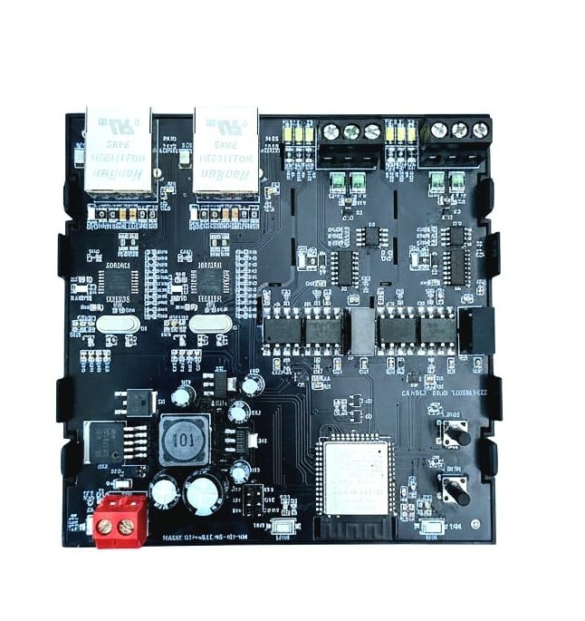
RS485-1
ETH-2
ETH-1
RS485-2

12-24V
DC supply
Reset Pins

For More Details: http://www.youtube.com/@wittelb

Contact Us:
Augmatic Technology Pvt.Ltd.,
Plot no 6, shah industrial Estate II,
Kotambi, Vadodara – 391510.
Email – Sales@wittelb.com
Support: support@wittelb.raiseaticket.com / +91 94038 92805

